|  |  |
| --- | --- |
| SCM  System Context Management | |
| **Summary** | This is the Software Detailed Design Document |

|  |  |  |
| --- | --- | --- |
| **Author** | **Review** | **Approval** |
| Title: Madalina Serban | See Project Master Document for the roles and Project Members List for the name of people | See Project Master Document for the roles and Project Members List for the name of people |
|  |  |  |
| **Distribution** | | |
| See Project Master Document for the roles and Project Members List for the name of people | See Project Master Document for the roles and Project Members List for the name of people | See Project Master Document for the roles and Project Members List for the name of people |

# Table of content

1.1. Revision history * 4

1.2. Purpose and Scope 4

1.3. Referenced documents 4

1.3.1. External documents 4

1.3.2. Internal Documents 4

1.4. Terminology and definitions 4

2.1. Overview 5

2.2. Traceability 5

3.1. Services 5

3.1.1. scm_ManageSystemContextStorage 5

3.1.2. SCM_runMonitoreExecutedCycle 6

3.1.3. SCM_runGetLastKL30LostStatus 6

3.1.4. SCM_runGetLastTensioningState 7

3.1.5. SCM_runManageSystemContext 8

3.1.6. SCM_runRestoreSystemContext 8

3.1.7. SCM_runWriteSystemContextShutdown 9

3.1.8. SCM_CompareSystemContext 10

3.1.9. SCM_ComputeSystemContextChecksum 11

3.1.10. SCM_GetReleaseInterruptionFlags 12

3.1.11. SCM_PrepareSystemContextStorage 13

3.1.12. SCM_RecoverSystemContext 14

3.1.13. scm_RecoverSystemContextContent 15

3.1.14. SCM_runKL30bgSupervision 16

3.1.15. SCM_StoreSystemContext 16

3.2. Variabiles 17

3.2.1. SCM_u8LastInterruptedCycleNumber 17

3.2.2. SCM_u8LastInterruptedCycleNumber_Mirror 17

3.2.3. scm_b8NeedSystemContextToBeKeptForCycle 17

3.2.4. SCM_b8ReleaseHasToBeTriggered 18

3.2.5. scm_bIsSystemContextReallocationRequested 18

3.2.6. scm_bIsSystemContextShutdownStored 18

3.2.7. SCM_bIsSystemContextStorageRequested 18

3.2.8. SCM_ENTER_CRITICAL_SECTION 18

3.2.9. SCM_u32OldSystemTime 19

3.2.10. scm_u8ExecutedCycleMemory 19

3.2.11. SCM_au8AbortionFlagsArray 19

3.2.12. scm_kau8ProductionCycleIdList 19

3.2.13. scm_kau8ReleaseIdList 19

3.2.14. scm_kstDefautSystemContextValue 20

3.2.15. SCM_stSystemContextType 20

3.2.16. scm_u16BatteryHysteresisThrs 20

3.2.17. scm_u8IndexCurrentSystemContext 20

3.2.18. scm_u8LastPreparedIndex 20

3.2.19. SCM_u8SystemContextReallocationStatus 21

3.3. Macros 21

3.3.1. KU32_DELAY_SYSTEM_CONTEXT_STORAGE 21

3.3.2. KU32_KL30_MUL_FACTOR 21

3.3.3. KU32_KL30_DIV_FACTOR 21

3.3.4. KU8_SYSTEM_CONTEXT_BLOCK_ID_0 21

3.3.5. KU8_SYSTEM_CONTEXT_BLOCK_ID_1 22

3.3.6. KU8_SYSTEM_CONTEXT_BLOCK_ID_2 22

3.3.7. CAL_SCM_CYCLE_PRIORITY 22

3.4. Types 22

3.4.1. SCM_stSystemContextType 22

3.5. Constants 22

3.5.1. KU8_SYSTEM_CONTEXT_SIZE 22

3.5.2. KU8_MAX_SYSTEM_CONTEXT_SUBBLOCKS 23

3.5.3. KU8_REALLOCATION_NEEDED 23

3.5.4. KU8_REALLOCATION_STARTED 23

3.5.5. KU8_REALLOCATION_FINISHED 23

3.5.6. SCM_KU8_NUMBER_OF_RELEASE 23

3.5.7. SCM_KU8_NUMBER_OF_PRODUCTION_CYCLE 24

3.5.8. KU32_SW_PROTECTION_BIT_MASK 24

3.5.9. KU8_SW_PROTECTION_QUALIFIED_MASK 24

Table of Figures

Figure 1:scm_ManageSystemContextStorage 6

Figure 2: SCM_runMonitoreExecutedCycle 6

Figure 3: SCM_runGetLastKL30LostStatus 7

Figure 4: SCM_runGetLastTensioningState 8

Figure 5: SCM_runManageSystemContext 8

Figure 6: SCM_runRestoreSystemContext 9

Figure 7: SCM_runWriteSystemContextShutdown 10

Figure 8:SCM_CompareSystemContext 11

Figure 9: SCM_ComputeSystemContextChecksum 12

Figure 10: SCM_GetReleaseInterruptionFlags 13

Figure 11: SCM_PrepareSystemContextStorage 14

Figure 12: SCM_RecoverSystemContext 15

Figure 13: scm_RecoverSystemContextContent 16

Figure 14: SCM_runKL30bgSupervision 16

Figure 15:SCM_StoreSystemContext 17

# General Information

## Revision history *

|  |  |  |  |
| --- | --- | --- | --- |
| **Revision** | **Date** | **Author(s)** | **Description/comment** |
| 1.1.3.2 | 08.30.2023 | Madalina Serban | Initial revision |
| 1.1.3.3 | 08.30.2023 | Madalina Serban | Updated revision |
|  |  |  |  |

*\* Template history is found in the CM tool used for templates*

## Purpose and Scope

The review of this document is done thanks to …

The purpose of this document is…

## Referenced documents

### External documents

|  |  |  |
| --- | --- | --- |
| **Id** | **Title** | **Reference** |
|  |  |  |
|  |  |  |
|  |  |  |

### Internal Documents

|  |  |  |
| --- | --- | --- |
| **Id** | **Title** | **Reference** |
|  |  |  |
|  |  |  |
|  |  |  |
|  |  |  |

## Terminology and definitions

The generic acronyms are available in the [AEM process and method wiki](https://alvteams.alv.autoliv.int/sites/aeuaeequalityassurance/AEM%20Process%20wiki/acronyms.aspx)

|  |  |
| --- | --- |
| **Terminology** | **Meaning** |
| AAU | Atomic architectural unit |
| SW | software |
|  |  |

# SW Module Detailed Design

## Overview

## Traceability

# Features

## Services

### scm_ManageSystemContextStorage

|  |  |  |  |
| --- | --- | --- | --- |
| Object | | | |
| Function called in the context of a battery loss detection or standard shutdown situation. | | | |
| **Prototype** | | | |
| LOCAL void scm_ManageSystemContextStorage (const uint8 b8IsBatteryLoss) | | | |
| **Parameters** | | | |
| b8IsBatteryLoss - KU8_TRUE : function called in the context of a battery loss detection KU8_FALSE : function called in the context of a standard shutdown situation. | | | |
| **Exceptions** | | | |
| None. | | | |
| **Precondition** | | | |
| None. | | | |
| **Postcondition** | | | |
| None. | | | |
| **Input parameters** | | | |
| Name | Type | Description | Range |
| NA | NA | NA | NA |
| **Output parameters** | | | |
| Name | Type | Description | Range |
| NA | NA | NA | NA |
| **Return value** | | | |
| Type | Description | | |
| NA | None. | | |
| **Dynamic aspect** | | | |
| Who(callers) | Description | | |
| * | * | | |
| **Static aspect** | | | |
| * | | | |
| **Constrains** | | | |
|  | | | |



Figure :scm_ManageSystemContextStorage

### SCM_runMonitoreExecutedCycle

|  |  |  |  |
| --- | --- | --- | --- |
| Object | | | |
| Periodic function that shall be called with the same period that the Belt Function slack. | | | |
| **Prototype** | | | |
| EXPORTED void SCM_runMonitoreExecutedCycle (void) | | | |
| **Parameters** | | | |
| None | | | |
| **Exceptions** | | | |
| None | | | |
| **Precondition** | | | |
| None | | | |
| **Postcondition** | | | |
| None | | | |
| **Input parameters** | | | |
| Name | Type | Description | Range |
| NA | NA | NA | NA |
| **Output parameters** | | | |
| Name | Type | Description | Range |
| NA | NA | NA | NA |
| **Return value** | | | |
| Type | Description | | |
| NA | None | | |
| **Dynamic aspect** | | | |
| Who(callers) | Description | | |
| * | * | | |
| **Static aspect** | | | |
| * | | | |
| **Constrains** | | | |
|  | | | |



Figure : SCM_runMonitoreExecutedCycle

### SCM_runGetLastKL30LostStatus

|  |  |  |  |
| --- | --- | --- | --- |
| Object | | | |
| Callback function provided to the rest of the application to get the KL30 loss status. | | | |
| **Prototype** | | | |
| EXPORTED void SCM_runGetLastKL30LostStatus (b8BooleanType * pb8WasKl30Lost) | | | |
| **Parameters** | | | |
| pb8WasKl30Lost - KU8_TRUE : means that the KL30 has been lost KU8_FALSE : means that no battery cut has been detected by the application | | | |
| **Exceptions** | | | |
| None | | | |
| **Precondition** | | | |
| None | | | |
| **Postcondition** | | | |
| None | | | |
| **Input parameters** | | | |
| Name | Type | Description | Range |
| NA | NA | NA | NA |
| **Output parameters** | | | |
| Name | Type | Description | Range |
| NA | NA | NA | NA |
| **Return value** | | | |
| Type | Description | | |
| NA | None | | |
| **Dynamic aspect** | | | |
| Who(callers) | Description | | |
| * | * | | |
| **Static aspect** | | | |
| * | | | |
| **Constrains** | | | |
|  | | | |



Figure : SCM_runGetLastKL30LostStatus

### SCM_runGetLastTensioningState

|  |  |  |  |
| --- | --- | --- | --- |
| Object | | | |
| Callback function provided to the rest of the application to get the last tensioning state. | | | |
| **Prototype** | | | |
| EXPORTED void SCM_runGetLastTensioningState (u8CycleNumberType * pu8LastExecutedCycle) | | | |
| **Parameters** | | | |
| pu8LastExecutedCycle - Refer to the type scaling (RTE) for more details | | | |
| **Exceptions** | | | |
| None | | | |
| **Precondition** | | | |
| None | | | |
| **Postcondition** | | | |
| None | | | |
| **Input parameters** | | | |
| Name | Type | Description | Range |
| NA | NA | NA | NA |
| **Output parameters** | | | |
| Name | Type | Description | Range |
| NA | NA | NA | NA |
| **Return value** | | | |
| Type | Description | | |
| NA | None | | |
| **Dynamic aspect** | | | |
| Who(callers) | Description | | |
| * | * | | |
| **Static aspect** | | | |
| * | | | |
| **Constrains** | | | |
|  | | | |



Figure : SCM_runGetLastTensioningState

### SCM_runManageSystemContext

|  |  |  |  |
| --- | --- | --- | --- |
| Object | | | |
| Periodic main function that shall be called in the same task that the NV stack It collects all notifications from battery loss/recovery mechanism and supervises the executed belt function. | | | |
| **Prototype** | | | |
| EXPORTED void SCM_runManageSystemContext (void) | | | |
| **Parameters** | | | |
| None | | | |
| **Exceptions** | | | |
| None | | | |
| **Precondition** | | | |
| None | | | |
| **Postcondition** | | | |
| None | | | |
| **Input parameters** | | | |
| Name | Type | Description | Range |
| NA | NA | NA | NA |
| **Output parameters** | | | |
| Name | Type | Description | Range |
| NA | NA | NA | NA |
| **Return value** | | | |
| Type | Description | | |
| NA | None | | |
| **Dynamic aspect** | | | |
| Who(callers) | Description | | |
| * | * | | |
| **Static aspect** | | | |
| * | | | |
| **Constrains** | | | |
|  | | | |



Figure : SCM_runManageSystemContext

### SCM_runRestoreSystemContext

|  |  |  |  |
| --- | --- | --- | --- |
| Object | | | |
| Function called during Init sequence to load the last Valid system context stored in E2P This function shall not be called during the tasks scheduling !! | | | |
| **Prototype** | | | |
| EXPORTED void SCM_runRestoreSystemContext (void) | | | |
| **Parameters** | | | |
| None | | | |
| **Exceptions** | | | |
| None | | | |
| **Precondition** | | | |
| None | | | |
| **Postcondition** | | | |
| None | | | |
| **Input parameters** | | | |
| Name | Type | Description | Range |
| NA | NA | NA | NA |
| **Output parameters** | | | |
| Name | Type | Description | Range |
| NA | NA | NA | NA |
| **Return value** | | | |
| Type | Description | | |
| NA | None | | |
| **Dynamic aspect** | | | |
| Who(callers) | Description | | |
| * | * | | |
| **Static aspect** | | | |
| * | | | |
| **Constrains** | | | |
|  | | | |



Figure : SCM_runRestoreSystemContext

### SCM_runWriteSystemContextShutdown

|  |  |  |  |
| --- | --- | --- | --- |
| Object | | | |
| Function called during shutdown phase by ESM. | | | |
| **Prototype** | | | |
| EXPORTED void SCM_runWriteSystemContextShutdown (void) | | | |
| **Parameters** | | | |
| None | | | |
| **Exceptions** | | | |
| None | | | |
| **Precondition** | | | |
| None | | | |
| **Postcondition** | | | |
| None | | | |
| **Input parameters** | | | |
| Name | Type | Description | Range |
| NA | NA | NA | NA |
| **Output parameters** | | | |
| Name | Type | Description | Range |
| NA | NA | NA | NA |
| **Return value** | | | |
| Type | Description | | |
| NA | None | | |
| **Dynamic aspect** | | | |
| Who(callers) | Description | | |
| * | * | | |
| **Static aspect** | | | |
| * | | | |
| **Constrains** | | | |
|  | | | |



Figure : SCM_runWriteSystemContextShutdown

### SCM_CompareSystemContext

|  |  |  |  |
| --- | --- | --- | --- |
| Object | | | |
| Function called to compare the the current systeme context index with the context index declared into a WMBA frame. | | | |
| **Prototype** | | | |
| EXPORTED boolean SCM_CompareSystemContext (uint8 IndexWriteBlock) | | | |
| **Parameters** | | | |
| IndexWriteBlock - Index of system contexty block given into the frame | | | |
| **Exceptions** | | | |
| None. | | | |
| **Precondition** | | | |
| None. | | | |
| **Postcondition** | | | |
| None. | | | |
| **Input parameters** | | | |
| Name | Type | Description | Range |
| NA | NA | NA | NA |
| **Output parameters** | | | |
| Name | Type | Description | Range |
| NA | NA | NA | NA |
| **Return value** | | | |
| Type | Description | | |
| boolean | bCompareResult - True if it is the same index False if it is not the case | | |
| **Dynamic aspect** | | | |
| Who(callers) | Description | | |
| * | * | | |
| **Static aspect** | | | |
| * | | | |
| **Constrains** | | | |
|  | | | |

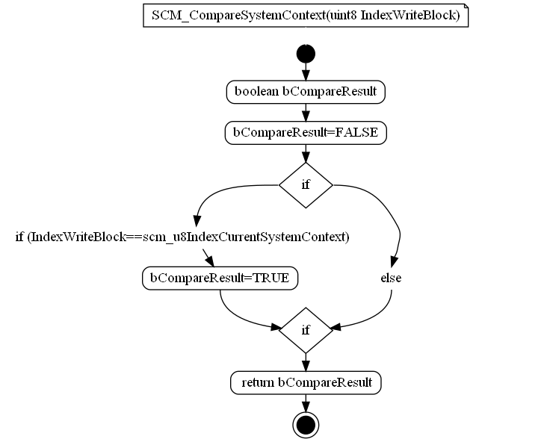

Figure :SCM_CompareSystemContext

### SCM_ComputeSystemContextChecksum

|  |  |  |  |
| --- | --- | --- | --- |
| Object | | | |
| This function is called to compute system context checksum. | | | |
| **Prototype** | | | |
| EXPORTED uint8 SCM_ComputeSystemContextChecksum (const SCM_stSystemContextType *const pstSystemContext) | | | |
| **Parameters** | | | |
| pstSystemContext - Pointer to the structure containing the data for which we need to compute a checksum. | | | |
| **Exceptions** | | | |
| None. | | | |
| **Precondition** | | | |
| None. | | | |
| **Postcondition** | | | |
| None. | | | |
| **Input parameters** | | | |
| Name | Type | Description | Range |
| NA | NA | NA | NA |
| **Output parameters** | | | |
| Name | Type | Description | Range |
| NA | NA | NA | NA |
| **Return value** | | | |
| Type | Description | | |
| uint8 | u8ChkSum - hecksum value for the system context structure passed as argument. | | |
| **Dynamic aspect** | | | |
| Who(callers) | Description | | |
| * | * | | |
| **Static aspect** | | | |
| * | | | |
| **Constrains** | | | |
|  | | | |

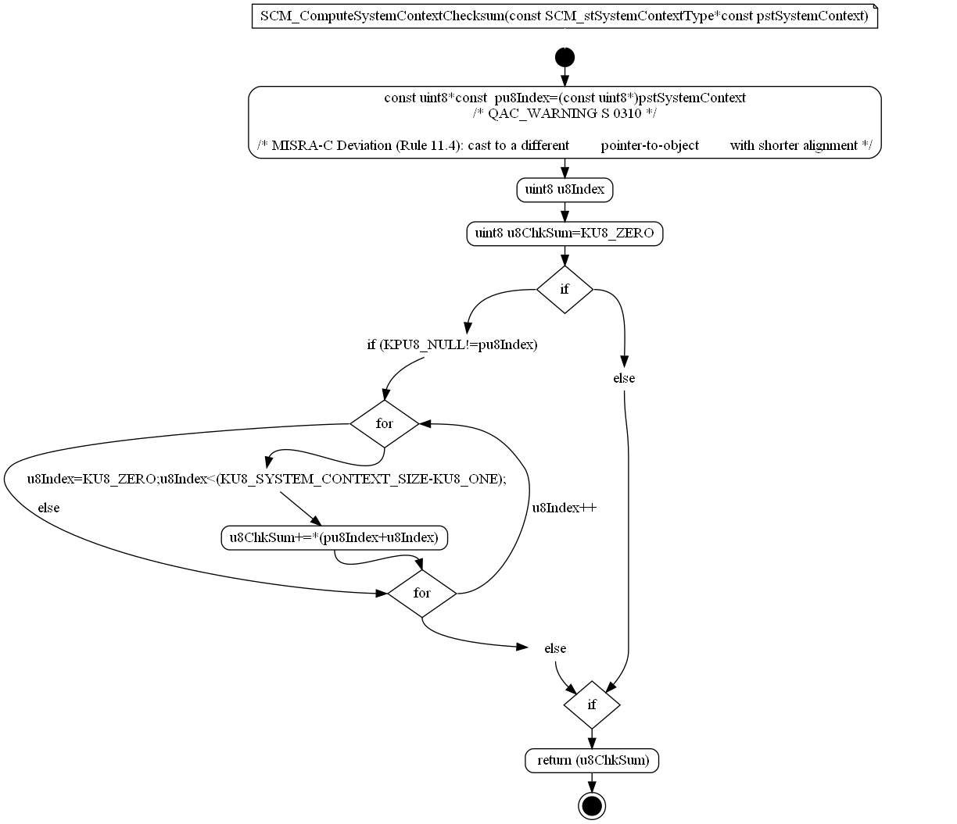

Figure : SCM_ComputeSystemContextChecksum

### SCM_GetReleaseInterruptionFlags

|  |  |  |  |
| --- | --- | --- | --- |
| Object | | | |
| Specific function to retrieve all interruption flags from BFD release algo This function is hand coded without function pointers because the RTE macros generated by SystemDesk are *********** and can't be handled in a generic way. | | | |
| **Prototype** | | | |
| EXPORTED void SCM_GetReleaseInterruptionFlags (void) | | | |
| **Parameters** | | | |
| None. | | | |
| **Exceptions** | | | |
| None. | | | |
| **Precondition** | | | |
| None. | | | |
| **Postcondition** | | | |
| None. | | | |
| **Input parameters** | | | |
| Name | Type | Description | Range |
| NA | NA | NA | NA |
| **Output parameters** | | | |
| Name | Type | Description | Range |
| NA | NA | NA | NA |
| **Return value** | | | |
| Type | Description | | |
| NA | None. | | |
| **Dynamic aspect** | | | |
| Who(callers) | Description | | |
| * | * | | |
| **Static aspect** | | | |
| * | | | |
| **Constrains** | | | |
|  | | | |

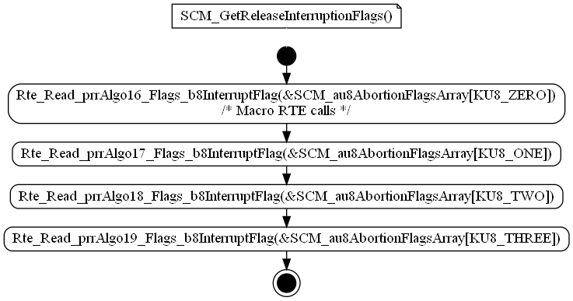

Figure : SCM_GetReleaseInterruptionFlags

### SCM_PrepareSystemContextStorage

|  |  |  |  |
| --- | --- | --- | --- |
| Object | | | |
| Specific function to prepare the E2P blocks before a write operation. | | | |
| **Prototype** | | | |
| EXPORTED void SCM_PrepareSystemContextStorage (void) | | | |
| **Parameters** | | | |
| None. | | | |
| **Exceptions** | | | |
| None. | | | |
| **Precondition** | | | |
| None. | | | |
| **Postcondition** | | | |
| None. | | | |
| **Input parameters** | | | |
| Name | Type | Description | Range |
| NA | NA | NA | NA |
| **Output parameters** | | | |
| Name | Type | Description | Range |
| NA | NA | NA | NA |
| **Return value** | | | |
| Type | Description | | |
| NA | None. | | |
| **Dynamic aspect** | | | |
| Who(callers) | Description | | |
| * | * | | |
| **Static aspect** | | | |
| * | | | |
| **Constrains** | | | |
|  | | | |

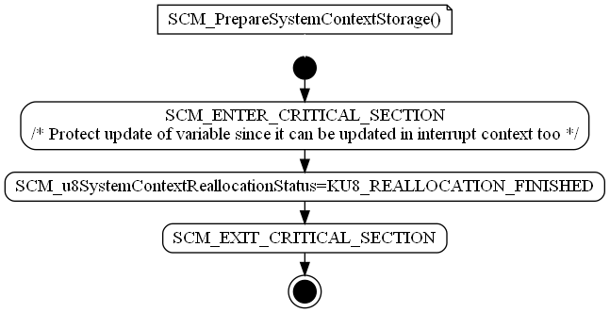

Figure : SCM_PrepareSystemContextStorage

### SCM_RecoverSystemContext

|  |  |  |  |
| --- | --- | --- | --- |
| Object | | | |
| Specific function to recover System Context and select the more recent one. Callback function provided to the rest of the application to get the KL30 loss status. | | | |
| **Prototype** | | | |
| EXPORTED void SCM_RecoverSystemContext (void) | | | |
| **Parameters** | | | |
| None. | | | |
| **Exceptions** | | | |
| None. | | | |
| **Precondition** | | | |
| None. | | | |
| **Postcondition** | | | |
| None. | | | |
| **Input parameters** | | | |
| Name | Type | Description | Range |
| NA | NA | NA | NA |
| **Output parameters** | | | |
| Name | Type | Description | Range |
| NA | NA | NA | NA |
| **Return value** | | | |
| Type | Description | | |
| NA | None. | | |
| **Dynamic aspect** | | | |
| Who(callers) | Description | | |
| * | * | | |
| **Static aspect** | | | |
| * | | | |
| **Constrains** | | | |
|  | | | |



Figure : SCM_RecoverSystemContext

### scm_RecoverSystemContextContent

|  |  |  |  |
| --- | --- | --- | --- |
| Object | | | |
| The goal of this private function is to perform a read operation on a System context block in E2P during Init sequence This function shall not be called if the NV stack is already running !!!! | | | |
| **Prototype** | | | |
| LOCAL void scm_RecoverSystemContextContent (const uint8 cu8ScIndex, SCM_stSystemContextType *const pstSystContext) | | | |
| **Parameters** | | | |
| cu8ScIndex - Block Identifier value that will be read during function execution pstSystContext - Pointer used as an output parameter to store the system context data | | | |
| **Exceptions** | | | |
| None. | | | |
| **Precondition** | | | |
| None. | | | |
| **Postcondition** | | | |
| None. | | | |
| **Input parameters** | | | |
| Name | Type | Description | Range |
| NA | NA | NA | NA |
| **Output parameters** | | | |
| Name | Type | Description | Range |
| NA | NA | NA | NA |
| **Return value** | | | |
| Type | Description | | |
| NA | None. | | |
| **Dynamic aspect** | | | |
| Who(callers) | Description | | |
| * | * | | |
| **Static aspect** | | | |
| * | | | |
| **Constrains** | | | |
|  | | | |



Figure : scm_RecoverSystemContextContent

### SCM_runKL30bgSupervision

|  |  |  |  |
| --- | --- | --- | --- |
| Object | | | |
| Function call under ADC interrupt context to check the battery loss hysteresis. | | | |
| **Prototype** | | | |
| EXPORTED void SCM_runKL30bgSupervision (u16SampledSignalType u16KL30bgLevel) | | | |
| **Parameters** | | | |
| u16KL30bgAdcLevel - Logic Supply level directly read from ADC peripheral without rescaling. | | | |
| **Exceptions** | | | |
| None. | | | |
| **Precondition** | | | |
| None. | | | |
| **Postcondition** | | | |
| None. | | | |
| **Input parameters** | | | |
| Name | Type | Description | Range |
| NA | NA | NA | NA |
| **Output parameters** | | | |
| Name | Type | Description | Range |
| NA | NA | NA | NA |
| **Return value** | | | |
| Type | Description | | |
| NA | None. | | |
| **Dynamic aspect** | | | |
| Who(callers) | Description | | |
| * | * | | |
| **Static aspect** | | | |
| * | | | |
| **Constrains** | | | |
|  | | | |



Figure : SCM_runKL30bgSupervision

### SCM_StoreSystemContext

|  |  |  |  |
| --- | --- | --- | --- |
| Object | | | |
| This function is called to manage the system context write operation. | | | |
| **Prototype** | | | |
| EXPORTED void SCM_StoreSystemContext (void) | | | |
| **Parameters** | | | |
| None. | | | |
| **Exceptions** | | | |
| None. | | | |
| **Precondition** | | | |
| None. | | | |
| **Postcondition** | | | |
| None. | | | |
| **Input parameters** | | | |
| Name | Type | Description | Range |
| NA | NA | NA | NA |
| **Output parameters** | | | |
| Name | Type | Description | Range |
| NA | NA | NA | NA |
| **Return value** | | | |
| Type | Description | | |
| NA | None. | | |
| **Dynamic aspect** | | | |
| Who(callers) | Description | | |
| * | * | | |
| **Static aspect** | | | |
| * | | | |
| **Constrains** | | | |
|  | | | |



Figure :SCM_StoreSystemContext

## Variabiles

### SCM_u8LastInterruptedCycleNumber

|  |  |  |
| --- | --- | --- |
| Type | Value |  |
| uint8 | NA | |
| **Description** | | |
| Buffer for system context in order to know what belt function Id shall be stored in NVM during shutdown. | | |
| **Definition** | | |
| uint8 SCM_u8LastInterruptedCycleNumber | | |
| **Remarks** | | |
| None. | | |

### SCM_u8LastInterruptedCycleNumber_Mirror

|  |  |  |
| --- | --- | --- |
| Type | Value |  |
| uint8 | NA | |
| **Description** | | |
| Mirror data to validate data integrityMirror data to validate data integrity | | |
| **Definition** | | |
| uint8 SCM_u8LastInterruptedCycleNumber_Mirror | | |
| **Remarks** | | |
| None. | | |

### scm_b8NeedSystemContextToBeKeptForCycle

|  |  |  |
| --- | --- | --- |
| Type | Value |  |
| uint8 | KU8_FALSE | |
| **Description** | | |
| Indicates if system context needs to be saved. | | |
| **Definition** | | |
| LOCAL uint8 scm_b8NeedSystemContextToBeKeptForCycle = KU8_FALSE | | |
| **Remarks** | | |
| None. | | |

### SCM_b8ReleaseHasToBeTriggered

|  |  |  |
| --- | --- | --- |
| Type | Value |  |
| uint8 | KU8_FALSE | |
| **Description** | | |
| Data to know if a Release has to be triggered. | | |
| **Definition** | | |
| EXPORTED uint8 SCM_b8ReleaseHasToBeTriggered = KU8_FALSE | | |
| **Remarks** | | |
| None. | | |

### scm_bIsSystemContextReallocationRequested

|  |  |  |
| --- | --- | --- |
| Type | Value |  |
| boolean | KU8_FALSE | |
| **Description** | | |
| Boolean set to TRUE when the battery level is OK after a battery loss situation. | | |
| **Definition** | | |
| LOCAL boolean scm_bIsSystemContextReallocationRequested = KU8_FALSE | | |
| **Remarks** | | |
| None. | | |

### scm_bIsSystemContextShutdownStored

|  |  |  |
| --- | --- | --- |
| Type | Value |  |
| boolean | KU8_FALSE | |
| **Description** | | |
| Boolean write in shutdown in order to perform only one time the saving of System context. | | |
| **Definition** | | |
| LOCAL boolean scm_bIsSystemContextShutdownStored = KU8_FALSE | | |
| **Remarks** | | |
| None. | | |

### SCM_bIsSystemContextStorageRequested

|  |  |  |
| --- | --- | --- |
| Type | Value |  |
| boolean | KU8_FALSE | |
| **Description** | | |
| Boolean set to TRUE when a battery loss is detected. | | |
| **Definition** | | |
| EXPORTED boolean SCM_bIsSystemContextStorageRequested = KU8_FALSE | | |
| **Remarks** | | |
| None. | | |

### SCM_ENTER_CRITICAL_SECTION

|  |  |  |
| --- | --- | --- |
| Type | Value |  |
|  | NA | |
| **Description** | | |
| This variable is used to ... | | |
| **Definition** | | |
| SCM_ENTER_CRITICAL_SECTION | | |

### SCM_u32OldSystemTime

|  |  |  |
| --- | --- | --- |
| Type | Value |  |
| uint32 | KU32_ZERO | |
| **Description** | | |
| Data to store the last System Time used for the last System Context telegram. | | |
| **Definition** | | |
| EXPORTED uint32 SCM_u32OldSystemTime = KU32_ZERO | | |
| **Remarks** | | |
| None. | | |

### scm_u8ExecutedCycleMemory

|  |  |  |
| --- | --- | --- |
| Type | Value |  |
| u8CycleNumberType | KU8_NO_CYCLE | |
| **Description** | | |
| Previous Executed cycle.Only used by SCM_runMonitoreExecutedCycle. | | |
| **Definition** | | |
| LOCAL u8CycleNumberType scm_u8ExecutedCycleMemory = KU8_NO_CYCLE | | |
| **Remarks** | | |
| None. | | |

### SCM_au8AbortionFlagsArray

|  |  |  |
| --- | --- | --- |
| Type | Value |  |
| uint8 | NA | |
| **Description** | | |
| Abortion flags for Release cycles. | | |
| **Definition** | | |
| uint8 SCM_au8AbortionFlagsArray[SCM_KU8_NUMBER_OF_RELEASE] | | |
| **Remarks** | | |
| None. | | |

### scm_kau8ProductionCycleIdList

|  |  |  |
| --- | --- | --- |
| Type | Value |  |
| const u8CycleNumberType | NA | |
| **Description** | | |
| Production cycles. | | |
| **Definition** | | |
| const u8CycleNumberType scm_kau8ProductionCycleIdList[SCM_KU8_NUMBER_OF_PRODUCTION_CYCLE] | | |
| **= {** | | |
| 19u , 20u | | |
| **Remarks** | | |
| None. | | |

### scm_kau8ReleaseIdList

|  |  |  |
| --- | --- | --- |
| Type | Value |  |
| const u8CycleNumberType | NA | |
| **Description** | | |
| Release belt function position in the cycle library. | | |
| **Definition** | | |
| const u8CycleNumberType scm_kau8ReleaseIdList[SCM_KU8_NUMBER_OF_RELEASE] | | |
| **= {** | | |
| 15u , 16u , 17u , 18u | | |
| **Remarks** | | |
| None. | | |

### scm_kstDefautSystemContextValue

|  |  |  |
| --- | --- | --- |
| Type | Value |  |
| const SCM_stSystemContextType | NA | |
| **Description** | | |
| Default value for system Context in case of recovery error. | | |
| **Definition** | | |
| const SCM_stSystemContextType scm_kstDefautSystemContextValue | | |
| **= {** | | |
| 0u , 0u , B_FALSE , KU8_NO_CYCLE , B_FALSE , KU8_MAX | | |
| **Remarks** | | |
| None. | | |

### SCM_stSystemContextType

|  |  |  |
| --- | --- | --- |
| Type | Value |  |
| SCM_stSystemContextType | NA | |
| **Description** | | |
| Variable used to store the current system context | | |
| **Definition** | | |
| EXPORTED SCM_stSystemContextType SCM_stCurrentSystemContextContent | | |

### scm_u16BatteryHysteresisThrs

|  |  |  |
| --- | --- | --- |
| Type | Value |  |
| uint16 | KU16_ZERO | |
| **Description** | | |
| Local variable which holds the treshold for battery loss. | | |
| **Definition** | | |
| LOCAL uint16 scm_u16BatteryHysteresisThrs = KU16_ZERO | | |
| **Remarks** | | |
| None. | | |

### scm_u8IndexCurrentSystemContext

|  |  |  |
| --- | --- | --- |
| Type | Value |  |
| uint8 | NA | |
| **Description** | | |
| Local variable which indicates which NvM block of system context is currently used. | | |
| **Definition** | | |
| LOCAL uint8 scm_u8IndexCurrentSystemContext | | |
| **Remarks** | | |
| None. | | |

### scm_u8LastPreparedIndex

|  |  |  |
| --- | --- | --- |
| Type | Value |  |
| uint8 | KU8_ZERO | |
| **Description** | | |
| Local variable which indicates which NvM block of system context was last used. | | |
| **Definition** | | |
| LOCAL uint8 scm_u8LastPreparedIndex = KU8_ZERO | | |
| **Remarks** | | |
| None. | | |

### SCM_u8SystemContextReallocationStatus

|  |  |  |
| --- | --- | --- |
| Type | Value |  |
| uint8 | KU8_REALLOCATION_FINISHED | |
| **Description** | | |
| Variable used to store system context reallocation status | | |
| **Definition** | | |
| EXPORTED uint8 SCM_u8SystemContextReallocationStatus = KU8_REALLOCATION_FINISHED | | |

## Macros

### KU32_DELAY_SYSTEM_CONTEXT_STORAGE

|  |  |
| --- | --- |
| Name | Value |
| KU32_DELAY_SYSTEM_CONTEXT_STORAGE | ((uint32)1) |
| **Definition** | |
| #define KU32_DELAY_SYSTEM_CONTEXT_STORAGE ((uint32)1) | |
| **Description** | |
| Value for system context storage delay | |

### KU32_KL30_MUL_FACTOR

|  |  |
| --- | --- |
| Name | Value |
| KU32_KL30_MUL_FACTOR | ((uint32)6 * (uint32)5000) |
| **Definition** | |
| #define KU32_KL30_MUL_FACTOR ((uint32)6 * (uint32)5000) | |
| **Description** | |
| KL30 & KL30bg multiply factor to be applied on voltage threshold parameters to convert from mV into 10 bits ADC raw format. | |

### KU32_KL30_DIV_FACTOR

|  |  |
| --- | --- |
| Name | Value |
| KU32_KL30_DIV_FACTOR | ((uint32) 1024) |
| **Definition** | |
| #define KU32_KL30_DIV_FACTOR ((uint32) 1024) | |
| **Description** | |
| KL30 & KL30bg divide factor to be applied on voltage threshold parameters to convert from mV into 10 bits ADC raw format. | |

### KU8_SYSTEM_CONTEXT_BLOCK_ID_0

|  |  |
| --- | --- |
| Name | Value |
| KU8_SYSTEM_CONTEXT_BLOCK_ID_0 | ((uint8) 0) |
| **Definition** | |
| #define KU8_SYSTEM_CONTEXT_BLOCK_ID_0 ((uint8) 0) | |
| **Description** | |
| System context blocks ID 0 | |

### KU8_SYSTEM_CONTEXT_BLOCK_ID_1

|  |  |
| --- | --- |
| Name | Value |
| KU8_SYSTEM_CONTEXT_BLOCK_ID_1 | ((uint8) 1) |
| **Definition** | |
| #define KU8_SYSTEM_CONTEXT_BLOCK_ID_1 ((uint8) 1) | |
| **Description** | |
| System context blocks ID 1 | |

### KU8_SYSTEM_CONTEXT_BLOCK_ID_2

|  |  |
| --- | --- |
| Name | Value |
| KU8_SYSTEM_CONTEXT_BLOCK_ID_2 | ((uint8) 2) |
| **Definition** | |
| #define KU8_SYSTEM_CONTEXT_BLOCK_ID_2 ((uint8) 2) | |
| **Description** | |
| System context blocks ID 2 | |

### CAL_SCM_CYCLE_PRIORITY

|  |  |
| --- | --- |
| Name | Value |
| CAL_SCM_CYCLE_PRIORITY | (NVP_au8BeltFctPriorities[x]) |
| **Definition** | |
| CAL_SCM_CYCLE_PRIORITY(x) (NVP_au8BeltFctPriorities[x]) | |
|  | |
| Priority level for cycles | |

## Types

### SCM_stSystemContextType

|  |  |  |
| --- | --- | --- |
| **Field Name** | **Field Type** | **Field description** |
| u32StoreSystemTime | uint32 | System Time |
| u32StoreDeficiencyLevel | uint32 | Deficiency level |
| b8StoreKL30Lost | uint8 | KL30 battery loss |
| u8StoreExecutedCycle | uint8 | Executed Cycle |
| u8CPLstatus | uint16 | CPL Status |
| u8StoreSystemContextChecksum | uint8 | System Context Chesksum |

## Constants

### KU8_SYSTEM_CONTEXT_SIZE

|  |  |
| --- | --- |
| Name | Value |
| KU8_SYSTEM_CONTEXT_SIZE | ((uint8) sizeof(SCM_stSystemContextType)) |
| **Definition** | |
| #define KU8_SYSTEM_CONTEXT_SIZE ((uint8) sizeof(SCM_stSystemContextType)) | |
|  | |
| System context size | |

### KU8_MAX_SYSTEM_CONTEXT_SUBBLOCKS

|  |  |
| --- | --- |
| Name | Value |
| KU8_MAX_SYSTEM_CONTEXT_SUBBLOCKS | 3 |
| **Definition** | |
| #define KU8_MAX_SYSTEM_CONTEXT_SUBBLOCKS ((uint8) 3) | |
|  | |
| Number of System Context blocks configured in NVM | |

### KU8_REALLOCATION_NEEDED

|  |  |
| --- | --- |
| Name | Value |
| KU8_REALLOCATION_NEEDED | 0 |
| **Definition** | |
| #define KU8_REALLOCATION_NEEDED ((uint8) 0) | |
|  | |
| Value to indicate system context reallocation is needed | |

### KU8_REALLOCATION_STARTED

|  |  |
| --- | --- |
| Name | Value |
| KU8_REALLOCATION_STARTED | 1 |
| **Definition** | |
| #define KU8_REALLOCATION_STARTED ((uint8) 1) | |
|  | |
| Value to indicate system context reallocation is started | |

### KU8_REALLOCATION_FINISHED

|  |  |
| --- | --- |
| Name | Value |
| KU8_REALLOCATION_ FINISHED | 2 |
| **Definition** | |
| #define KU8_REALLOCATION_ FINISHED ((uint8) 2) | |
|  | |
| Value to indicate system context reallocation is finished | |

### SCM_KU8_NUMBER_OF_RELEASE

|  |  |
| --- | --- |
| Name | Value |
| SCM_KU8_NUMBER_OF_RELEASE | 4 |
| **Definition** | |
| #define SCM_KU8_NUMBER_OF_RELEASE ((uint8) 4) | |
|  | |
| Number of belt function for release | |

### SCM_KU8_NUMBER_OF_PRODUCTION_CYCLE

|  |  |
| --- | --- |
| Name | Value |
| SCM_KU8_NUMBER_OF_PRODUCTION_CYCLE | 2 |
| **Definition** | |
| #define SCM_KU8_NUMBER_OF_PRODUCTION_CYCLE ((uint8) 2) | |
|  | |
| Number of production cycle | |

### KU32_SW_PROTECTION_BIT_MASK

|  |  |
| --- | --- |
| Name | Value |
| KU32_SW_PROTECTION_BIT_MASK | ((uint32) 0xAA000000) |
| **Definition** | |
| #define KU32_SW_PROTECTION_BIT_MASK ((uint32) 0xAA000000) | |
|  | |
| Mask used to access the MSB of the deficiency level | |

### KU8_SW_PROTECTION_QUALIFIED_MASK

|  |  |
| --- | --- |
| Name | Value |
| KU8_SW_PROTECTION_QUALIFIED_MASK | ((uint8) 0xAA) |
| **Definition** | |
| #define KU8_SW_PROTECTION_QUALIFIED_MASK ((uint8) 0xAA) | |
|  | |
| Mask used to store SW protection qualified status | |

# EEPROM

# Configuration

# Compilation Options